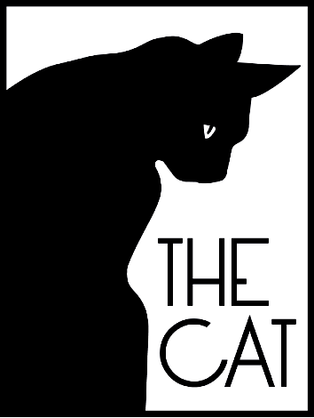
The Cat Inn, West Hoathly

31st December 2018

Canapés
***

Flamed & Cured Scottish Salmon, Cucumber Ketchup, Dill Mayonnaise

Surrey Beef Tartar, Crispy Quails Egg, Madeira Jelly, Caper Purée, Crispy Shallot

Heritage Beetroot, Innes Goats Curd, Comice Pear, Hazelnut

Sussex Wild Boar Scotch Egg, Bacon jam, Pink Lady Apple

***

Pan Fried Stone bass, Jerusalem Artichoke, Pancetta, Samphire, Caviar Veloute

Saddle of Lamb, Crispy Shoulder, Boulanger Potato, Savoy cabbage

Pumpkin & Sage Risotto, Forest Mushroom, Walnut Pesto, Crispy Black cabbage

Guinea Hen, Braised Leg, Chargrilled Polenta, Broccoli
***

Manjari 64% Chocolate Fondant, Salted Caramel, Almond Brittle

Brown Sugar Tart, Crème Fraiche, Black Sesame

Blackberry & Clementine Trifle

Selection of Sussex Artisan Cheeses

***

Coffee, Tea or Herbal Infusion

The Price for this menu is £78

The Cat Inn, Queens Square, West Hoathly, RH19 4PP Tel 01342 810369

www.catinn.co.uk

New Years Eve Order Form 2018

Please list each party member here with their menu choice below

Guest Names

Tick Menu Choice below
Starters
Salmon
Beef Tartar
Beetroot
Scotch Egg
Main Courses

Stone Bass
Lamb
Rissotto
Guinea Hen
Desserts
Chocolate Fondant
Brown Sugar Tart
Trifle
Artisan Cheeses

Booking in the Name of …………………………………………………………………………………………

Number of Guests……………………Telephone Number…………………………….

Address………………………………………………………………………………………………………………………………………

…………………………………………………………………………………..……………………………………………………………….

……………………………………………………Post Code……………

Email………………………………………………………………………

